Julian Bolster is an emerging leadership coach and motivational speaker based in downtown Toronto, Canada. Since his life-changing accident at eighteen, Julian has passionately pursued answers to the questions we all ask: Are my dreams possible? Do I have what it takes? How can I get there?

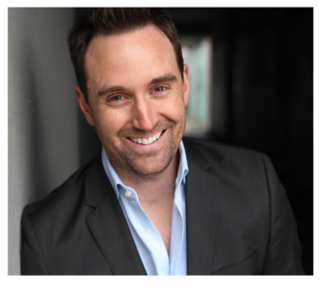

In his 20’s, Julian grew a small business services company to a national level, becoming the largest franchise of its kind in Canada. Over the past 20 years, he has developed his own proven techniques for achieving business success. His passion for inspiring others through the power of taking action led him to life coaching, where his clients have achieved incredible results. A uniquely insightful and charismatic coach and speaker, Julian shows people everyday that with the right tools, they can succeed in any goal and, even better, achieve their dream life - no matter their circumstances. Julian teaches that leadership is about taking charge and creating the results we desire in our lives. This applies to people of all walks of life, whether their goals are business-oriented or personal.
www.julianbolster.com
New Bearings Training & Coaching ・ 51 Wolseley Street, Toronto, Ontario M5T 1A4 ・ Main: 888.803.5433

About Julian Bolster

Follow us on twitter julianbolster
Stay tuned for details on Julian’s upcoming book with Deepak Chopra and Dr. Ken Blanchard, hitting bookstores this July 2012

Julian has studied at the University of Guelph and York University in Canada, as well as the internationally acclaimed CTI Coaches Training Institute, Landmark Education and Anthony Robbins Corporation, among others. He has a background in engineering, psychology and business, has gained the International CPCC and ACC coaching designations, and has worked with some of the top mentors in the world. Julian is the president and principal coach of New Bearings Training & Coaching, in Toronto. He is currently coaching, speaking, and delivering Leadership workshop programs for adults and youth.

Always on the go, Julian is a pilot, avid sailor, advisor to Junior Achievement in Toronto, volunteer and active community member.

